**Microsoft Azure Fundamentals: Working with Azure Virtual Machines**

**Azure Virtual Machines (VMs)**

* Windows client server OS images
* Linux OS images

**Virtual Machine Details**

* Resource group, location, VM name
* Image, size(vCPUs, RAM, number of data disks)
* OS credentials

1. VM extensions
2. Subnet, public IP address
3. Network security group, load balancing
4. Auto-shutdown, backup

**Azure Windows Virtual Machines**

* Specify logon credentials
* Connect using Remote Desktop Protocol (RDP)
* Ensure firewalls allow RDP
* Remote management trough Azure Bastion
  + Windows VM does not need a public IP Adress

**Azure Linux Virtual Machines**

* Authentication:
  + Username/password authentication
  + Public key authentication
* Remote management using Secure Shell (SSH)
* Ensure firewalls allow SSH (TCP port 22)
* Remote management through Azure Bastion
  + Linux VM does not need a public IP address

**Azure Virtual Machine Management**

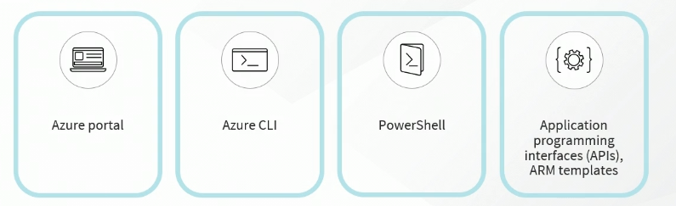

**Azure Virtual Machines Scale Set (VMSS)**

* Used with load balancing
* The scale set can be auto scaled
  + Scaling out
  + Scaling in
* VMs must be identical
  + Same OS image
* Spot instances

**Capturing a Custom Virtual Machine Image**

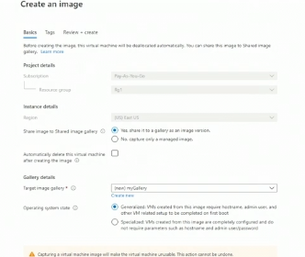

**Deploying Virtual Machines Using the Azure Portal**

Create a resource 🡪 Create a virtual machine

**Deploying Virtual Machines Using the Command Line Interface (CLI)**

Az find ‘vm’

Az find ‘vm create’

Az vm create --help

Az vm create --resource-group East --subnet subnet1 --vnet-name net1 --name win2022_srv1 --image MicrosoftWindowsServer:WindowsServer:2022-datacenter-azure-edition:latest --public-ip-sku Standard --admin-username cblackwell --admin-password Pa$$w0rdABC123 --location eastus

Az vm list

Az vm list --query [].name

Az vm image list --location eastus --publisher Microsoft --offer WindowsServer --sku 2022 --all --output table

**Deploying Virtual Machines Using PowerShell**

Get-AzVirtualNetwork | Select Name, Location

$vnet3=get-azvirtualnetwork -name vnet3

Get-azvirtualnetworksubnetconfig -virtualnetwork §vnet3

Get-azvmimageoffer -location eastus -publishername MicrosoftWindowsServer

Get-azvmimageoffer -location eastus -publishername MicrosoftWindowsServer -Offer WindowsServer | select skus

$creds=Get-Credential

$creds

New-AzVM `

-ResourceGroupName “East” `

-Name “winsrv2022-4” `

-Location “EastUS” `

-VirtualNetworkName “vnet3 “ `

-SubNetname “subnet1” `

-SecurityGroupName “Windows_Linux_NSG” `

-Image “MicrosoftWindowsServer:WindowsServer:2022-datacenter-azure-edition:latest” `

-OpenPorts 3389 `

-Credential $creds `

**Redeploying Virtual Machines**

Virtual machines 🡪 “win2022_srv1” 🡪 Redeploy + reapply

CLI

* Az vm --help
* Az vm redeploy --help

PowerShell

* Get-command *azvm*
* Get-help set-azvm -detail

**Resizing Virtual Machines Using the Azure Portal**

Create a resource 🡪 virtual machine 🡪 size

Virtual machines 🡪 “ubuntu-server1” 🡪 Size

Linux:

* lscpu
* cat /proc/meminfo
* top

Virtual machines 🡪 “ubuntu-server1” 🡪 Metrics

**Resizing Virtual Machines Using the CLI**

PowerShell:

get-azvm

$vm=get-azvm -resourcegroupname east -name win2022_srv1

$vm

$vm.hardwareprofile

$vm.hardwareprofile.vmsize

az vm list -g east --query [].’[name,hardwareProfile,vmSize]’

az vm list-vm-resize-options -g East -n win2022_srv1

az vm resize -g East -n win2022_srv1 --size Standard_DS3_v2

**Configuring Linux Secure Shell (SSH) Public Key Authentication**

Create a resource 🡪 virtual machine 🡪 SSH public key

* PuTTY “Key Generator” (Tool)

**Attaching a Managed Disk to a Virtual Machine**

Create a resource 🡪 Marketplace 🡪 Managed Disks 🡪 Create a managed disk

Virtual Machines 🡪 “ubuntu-server1” 🡪 Disks

**Enabling Virtual Machine Disk Encryption**

All rescources 🡪 “Windows_Data_Disk1” 🡪 Encryption (VM need to be stopped)

Customer managed key:

Create a resource 🡪 Marketplace 🡪 Key Vault 🡪 Create a key vault

“kveast-1” 🡪 Access Control (IAM) 🡪 Add role assignment

“kveast-1” 🡪 Keys 🡪 Generate/Import

Create a resource 🡪 Marketplace 🡪 Disk Encryption 🡪 Create a disk encryption set

**Deploying Virtual Machine Extensions**

Virtual machines 🡪 “win2022-srv2” 🡪 Extensions + applications (Stop virtual machine)

Virtual machines 🡪 “ubuntu-server2” 🡪 Extensions + applications 🡪 Add

**Capturing a Virtual Machine Image**

Virtual Machines 🡪 “ubuntu-server1” 🡪 Capture 🡪 Create an image

**Azure Virtual Desktop (AVD)**

Cloud-based user virtual machines; Desktop as a Service (DaaS)

Remote virtual dekstops apps running on a Windows client OS in the cloud (not locally)

**Azure Virtual Desktop Accessibility**

* Client device web browser on Windows, Linux, macOS (IE 11+, Edge, Safari, Firefox, Chrome)
* Windows AVD client for Start Menu integration, macOS Microsoft Remote Desktop client, iOS, and Android client support

**Azure Virtual Desktop Authentication**

* User account must exist in Azure AD
* Users must be assigned to use AVD and apps
* Consider enabling multi-factor authentication (MFA)
* Consider enabling conditional access policies (device being used, user IP subnet, or geographical location)

**AVD Host Pools**

Grouping of identical VMs based on the same VM image

Two types:

Personal: A user is assigned to a VM

Pooled: VM accepts any authorized user

**AVD App Group**

Grouping of apps

Two types: Desktop, RemoteApp

Users are assigned to app groups

**Azure Virtual Desktop Configuration: Azure Portal**

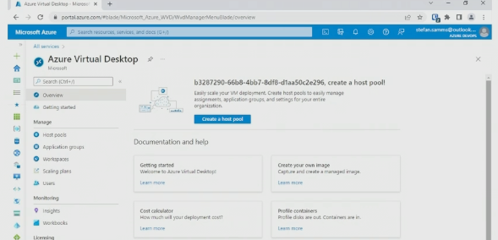

**Creating an AVD Host Pool**

Home 🡪 Azure Virtual Desktop 🡪 Create a host pool

**Using a Web Browser to Access AVD**

All resources 🡪 “AVD-HostPool1-East” 🡪 Application groups 🡪 “AVD-HostPool1-East-DAG” 🡪 Assignments

All resources 🡪 “AVD-HostPool1-East” 🡪 Session hosts

All resources 🡪 “ws1” (workspace) 🡪 Application groups

Virtual machines 🡪 East 🡪 Access control (IAM)

Browser:

Rdweb.wvd.microsoft.com

Client.wvd.microsoft.com/arm/webclient/index.html

**Implementing Microsoft Defender for Cloud**

Storage accounts 🡪 “storacctapp100” 🡪 Microsoft Defender for Cloud

Virtual machines 🡪 “win2022_srv1” 🡪 Microsoft Defender for Cloud

App services 🡪 “webapp100yhz” 🡪 Microsoft Defender for Cloud

Home 🡪 Microsoft Defender for Cloud